**INFORME SOLUCION PC01 SQL ADMINISTRACION**

**De acuerdo a los enunciados, los pasos realizados fueron los siguientes:**

* Ejecución del Script de la BD Northwind
* Inicio de sesión con autenticación de Windows

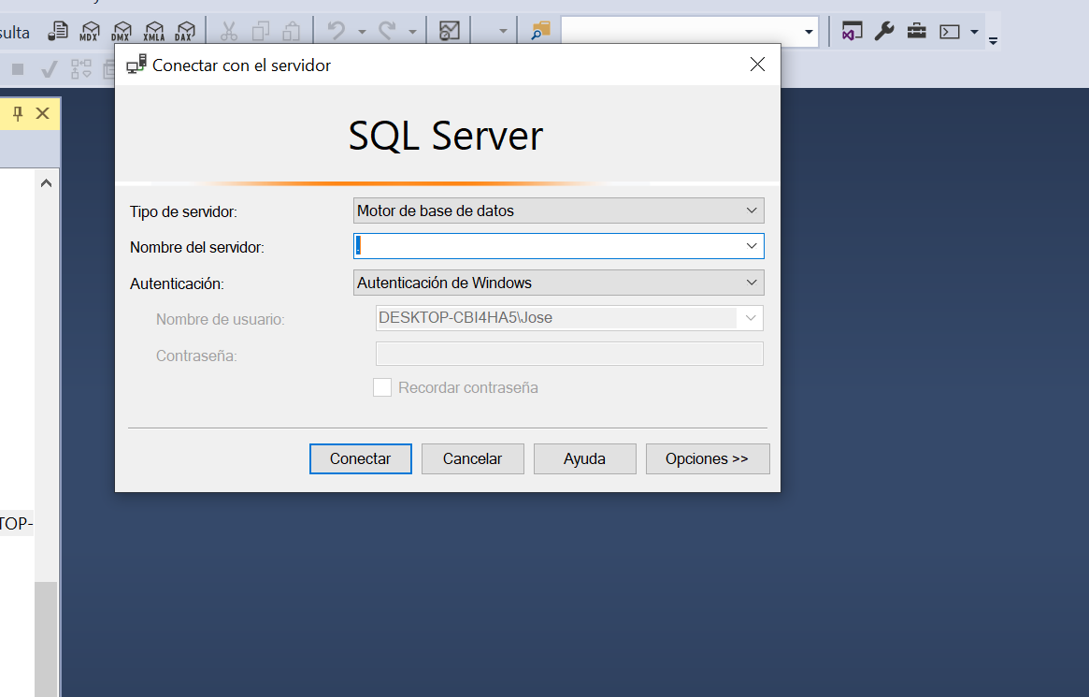

* Ejecución del Script de la BD Northwind
* Creación de los Inicios de Sesión, de la siguiente manera:

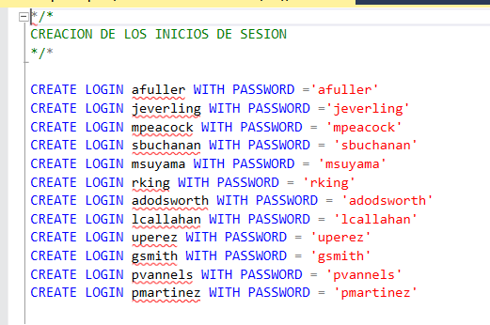

* Creación de los Usuarios para cada Login en la BD Northwind:

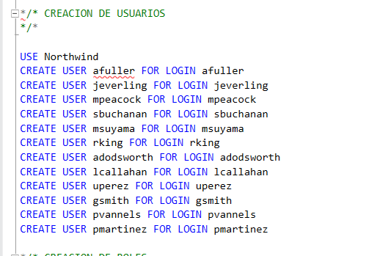

* Se crearon los roles de acuerdo a cada tarea que realizan los usuarios. Ejemplo: Select, Update, Delete, Insert y en algunos casos se denegó la acción delete, todo esto a nivel de las tablas a las cuales tienen acceso.

/* CREACION DE ROLES*/

--VICEPRESIDENTE

USE [Northwind]

CREATE ROLE [db_vicepresidente]

GRANT UPDATE ON [dbo].[Employees] TO [db_vicepresidente]

GRANT DELETE ON [dbo].[Employees] TO [db_vicepresidente]

GRANT INSERT ON [dbo].[Employees] TO [db_vicepresidente]

GRANT SELECT ON [dbo].[Order Details] TO [db_vicepresidente]

GRANT SELECT ON [dbo].[Orders] TO [db_vicepresidente]

GO

--VENDEDOR CORPORATIVO

USE [Northwind]

CREATE ROLE [db_vendedorcorporativo]

GRANT UPDATE ON [dbo].[Order Details] TO [db_vendedorcorporativo]

GRANT DELETE ON [dbo].[Order Details] TO [db_vendedorcorporativo]

GRANT INSERT ON [dbo].[Order Details] TO [db_vendedorcorporativo]

GRANT UPDATE ON [dbo].[Orders] TO [db_vendedorcorporativo]

GRANT DELETE ON [dbo].[Orders] TO [db_vendedorcorporativo]

GRANT INSERT ON [dbo].[Orders] TO [db_vendedorcorporativo]

GO

--GERENTE DE VENTAS

USE [Northwind]

CREATE ROLE [db_gerentedeventas]

GRANT DELETE ON [dbo].[Order Details] TO [db_gerentedeventas]

GRANT UPDATE ON [dbo].[Categories] TO [db_gerentedeventas]

GRANT DELETE ON [dbo].[Categories] TO [db_gerentedeventas]

GRANT INSERT ON [dbo].[Categories] TO [db_gerentedeventas]

GRANT DELETE ON [dbo].[Orders] TO [db_gerentedeventas]

GRANT UPDATE ON [dbo].[Products] TO [db_gerentedeventas]

GRANT DELETE ON [dbo].[Products] TO [db_gerentedeventas]

GRANT INSERT ON [dbo].[Products] TO [db_gerentedeventas]

GRANT UPDATE ON [dbo].[Suppliers] TO [db_gerentedeventas]

GRANT DELETE ON [dbo].[Suppliers] TO [db_gerentedeventas]

GRANT INSERT ON [dbo].[Suppliers] TO [db_gerentedeventas]

GO

--VENDEDOR LOCAL

USE [Northwind]

CREATE ROLE [db_vendedorlocal]

GRANT UPDATE ON [dbo].[Order Details] TO [db_vendedorlocal]

GRANT INSERT ON [dbo].[Order Details] TO [db_vendedorlocal]

DENY DELETE ON [dbo].[Order Details] TO [db_vendedorlocal]

GRANT UPDATE ON [dbo].[Customers] TO [db_vendedorlocal]

GRANT INSERT ON [dbo].[Customers] TO [db_vendedorlocal]

DENY DELETE ON [dbo].[Customers] TO [db_vendedorlocal]

GRANT UPDATE ON [dbo].[Orders] TO [db_vendedorlocal]

GRANT INSERT ON [dbo].[Orders] TO [db_vendedorlocal]

DENY DELETE ON [dbo].[Orders] TO [db_vendedorlocal]

GO

--ADMINISTRADOR INTERNO

USE [Northwind]

CREATE ROLE [db_administradorinterno]

GRANT UPDATE ON [dbo].[Categories] TO [db_administradorinterno]

GRANT INSERT ON [dbo].[Categories] TO [db_administradorinterno]

GRANT UPDATE ON [dbo].[Shippers] TO [db_administradorinterno]

GRANT INSERT ON [dbo].[Shippers] TO [db_administradorinterno]

GRANT UPDATE ON [dbo].[Products] TO [db_administradorinterno]

GRANT INSERT ON [dbo].[Products] TO [db_administradorinterno]

GRANT UPDATE ON [dbo].[Suppliers] TO [db_administradorinterno]

GRANT INSERT ON [dbo].[Suppliers] TO [db_administradorinterno]

GO

--VENDEDOR DE TIENDA

USE [Northwind]

CREATE ROLE [db_vendedortienda]

GRANT UPDATE ON [dbo].[Orders] TO [db_vendedortienda]

GRANT DELETE ON [dbo].[Orders] TO [db_vendedortienda]

GRANT INSERT ON [dbo].[Orders] TO [db_vendedortienda]

GRANT UPDATE ON [dbo].[Order Details] TO [db_vendedortienda]

GRANT DELETE ON [dbo].[Order Details] TO [db_vendedortienda]

GRANT INSERT ON [dbo].[Order Details] TO [db_vendedortienda]

GO

* Finalmente, se asignó cada rol al usuario respectivo

